Author: Mahesh Santosh Bhakare

Employee ID: API2309

Batch: Greenfield Training Batch 31

Title: 1. Consider any 5 real time objects and create POJO classes respectively.

**Source Code -**

1. Employee.java

**package** com.apisero.greenfield;

**public** **class** Employee {

**private** String id;

**private** String name;

**private** String address;

**private** **float** salary;

**public** Employee(String id, String name, String address, **float** salary) {

**super**();

**this**.id = id;

**this**.name = name;

**this**.address = address;

**this**.salary = salary;

}

**public** String getId() {

**return** id;

}

**public** **void** setId(String id) {

**this**.id = id;

}

**public** String getName() {

**return** name;

}

**public** **void** setName(String name) {

**this**.name = name;

}

**public** String getAddress() {

**return** address;

}

**public** **void** setAddress(String address) {

**this**.address = address;

}

**public** **float** getSalary() {

**return** salary;

}

**public** **void** setSalary(**float** salary) {

**this**.salary = salary;

}

@Override

**public** String toString() {

**return** "Employee [getId()=" + getId() + ", getName()=" + getName() + ", getAddress()=" + getAddress()

+ ", getSalary()=" + getSalary() + "]";

}

}

Main.java

**package** com.apisero.greenfield;

**public** **class** Main {

**public** **static** **void** main(String[] args) {

Employee e1 = **new** Employee("API1234", "XYZ","PQR", 460000.00f);

System.***out***.println(e1);

Employee e2 = **new** Employee("API1235", "DEF","MNO", 510000.00f);

System.***out***.println(e2);

}

}

**Output -**

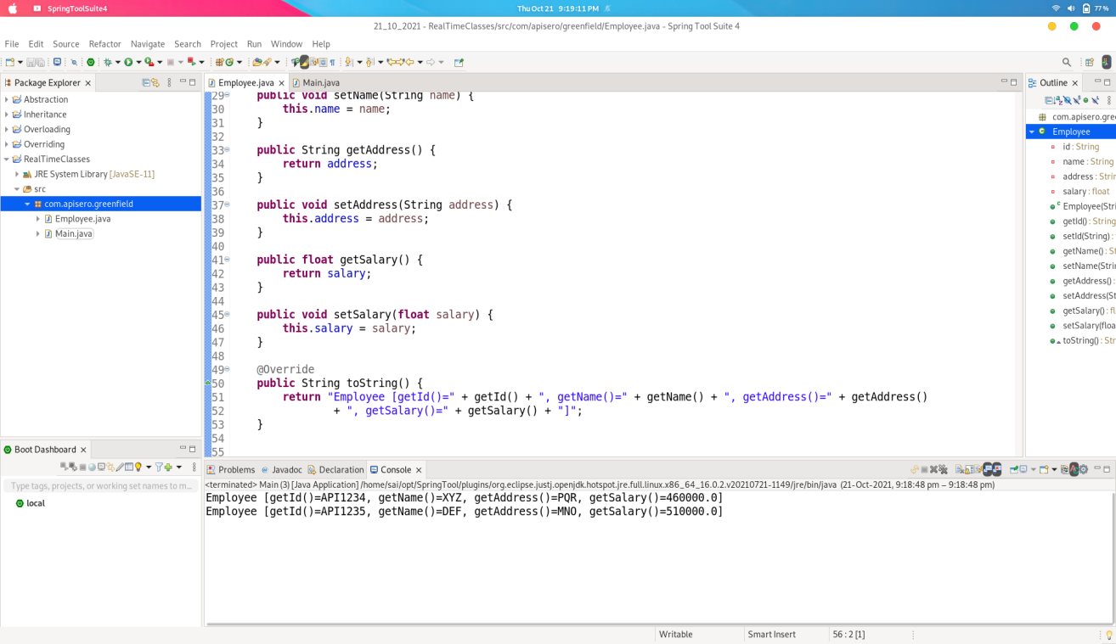

**Source Code -**

1. BankAccount.java -

**package** com.apisero.greenfield;

**public** **class** BankAccount {

**private** **static** String *bank_name*;

**private** String account_no;

**private** String account_holder_name;

**private** String ifsc_code;

**private** String bank_branch;

**private** **float** balance;

**public** BankAccount(String account_no, String account_holder_name, String ifsc_code, String bank_branch,

**float** balance) {

**super**();

**this**.account_no = account_no;

**this**.account_holder_name = account_holder_name;

**this**.ifsc_code = ifsc_code;

**this**.bank_branch = bank_branch;

**this**.balance = balance;

}

**public** **static** String getBank_name() {

**return** *bank_name*;

}

**public** **static** **void** setBank_name(String bank_name) {

BankAccount.*bank_name* = bank_name;

}

**public** String getAccount_no() {

**return** account_no;

}

**public** **void** setAccount_no(String account_no) {

**this**.account_no = account_no;

}

**public** String getAccount_holder_name() {

**return** account_holder_name;

}

**public** **void** setAccount_holder_name(String account_holder_name) {

**this**.account_holder_name = account_holder_name;

}

**public** String getIfsc_code() {

**return** ifsc_code;

}

**public** **void** setIfsc_code(String ifsc_code) {

**this**.ifsc_code = ifsc_code;

}

**public** String getBank_branch() {

**return** bank_branch;

}

**public** **void** setBank_branch(String bank_branch) {

**this**.bank_branch = bank_branch;

}

**public** **float** getBalance() {

**return** balance;

}

**public** **void** setBalance(**float** balance) {

**this**.balance = balance;

}

**public** **void** withdraw(**float** amount)

{

**if**((**this**.balance-amount)<0)

{

System.***out***.println("Insufficient Balance");

}

**else**

{

**this**.balance-=amount;

}

}

**public** **void** diposit(**float** amount)

{

**this**.balance+=amount;

}

@Override

**public** String toString() {

**return** "BankAccount [getAccount_no()=" + getAccount_no() + ", getAccount_holder_name()="

+ getAccount_holder_name() + ", getIfsc_code()=" + getIfsc_code() + ", getBank_branch()="

+ getBank_branch() + ", getBalance()=" + getBalance() + "]";

}

}

BankMain.java

**package** com.apisero.greenfield;

**public** **class** BankMain {

**public** **static** **void** main(String[] args) {

BankAccount.*setBank_name*("ICICI Bank Pvt. Ltd");

BankAccount mahesh = **new** BankAccount("123245671234","Mahesh Bhakare","ICIC0002345","Kopargaon",1000.00f);

System.***out***.print("Initial Status: ");

System.***out***.println(mahesh);

System.***out***.println();

mahesh.withdraw(500.00f);

System.***out***.print("Status after withdraw: ");

System.***out***.println(mahesh);

System.***out***.println();

mahesh.diposit(5000);

System.***out***.print("Status after diposit: ");

System.***out***.println(mahesh);

}

}

**Output -**

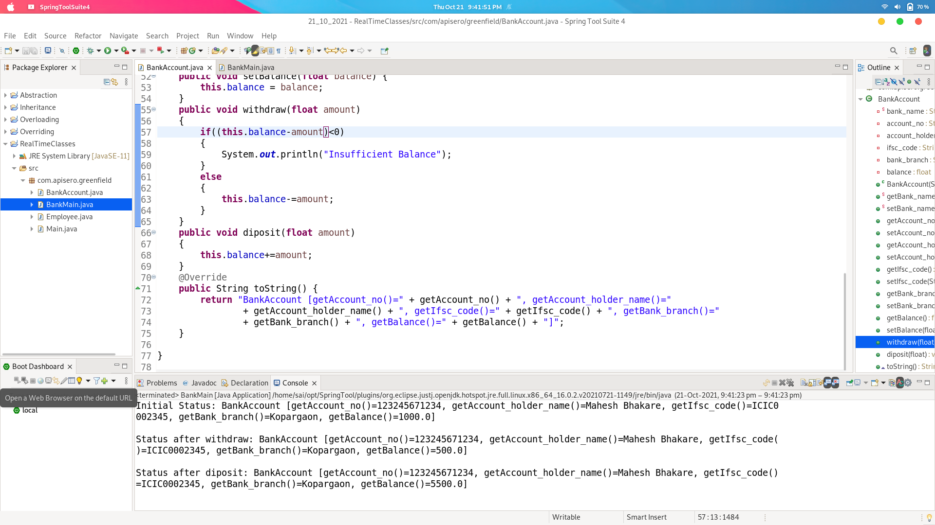

**Source Code -**

1. Bike.java -

**package** com.apisero.greenfield;

**public** **class** Bike {

**private** String Bike_no;

**private** String Chassis_no;

**private** String Owner_Name;

**private** String Ownned_Date;

**public** Bike(String bike_no, String chassis_no, String owner_Name, String ownned_Date) {

**super**();

Bike_no = bike_no;

Chassis_no = chassis_no;

Owner_Name = owner_Name;

Ownned_Date = ownned_Date;

}

**public** String getBike_no() {

**return** Bike_no;

}

**public** **void** setBike_no(String bike_no) {

Bike_no = bike_no;

}

**public** String getChassis_no() {

**return** Chassis_no;

}

**public** **void** setChassis_no(String chassis_no) {

Chassis_no = chassis_no;

}

**public** String getOwner_Name() {

**return** Owner_Name;

}

**public** **void** setOwner_Name(String owner_Name) {

Owner_Name = owner_Name;

}

**public** String getOwnned_Date() {

**return** Ownned_Date;

}

**public** **void** setOwnned_Date(String ownned_Date) {

Ownned_Date = ownned_Date;

}

@Override

**public** String toString() {

**return** "Bike [getBike_no()=" + getBike_no() + ", getChassis_no()=" + getChassis_no() + ", getOwner_Name()="

+ getOwner_Name() + ", getOwnned_Date()=" + getOwnned_Date() + "]";

}

}

BikeMain.java

**package** com.apisero.greenfield;

**public** **class** BikeMain {

**public** **static** **void** main(String[] args) {

Bike pulsur = **new** Bike("MH12BH1234", "qwer2345rtyu", "XYZ", "21-10-2021");

System.***out***.println(pulsur.getOwner_Name());

System.***out***.println(pulsur);

}

}

**Output:**

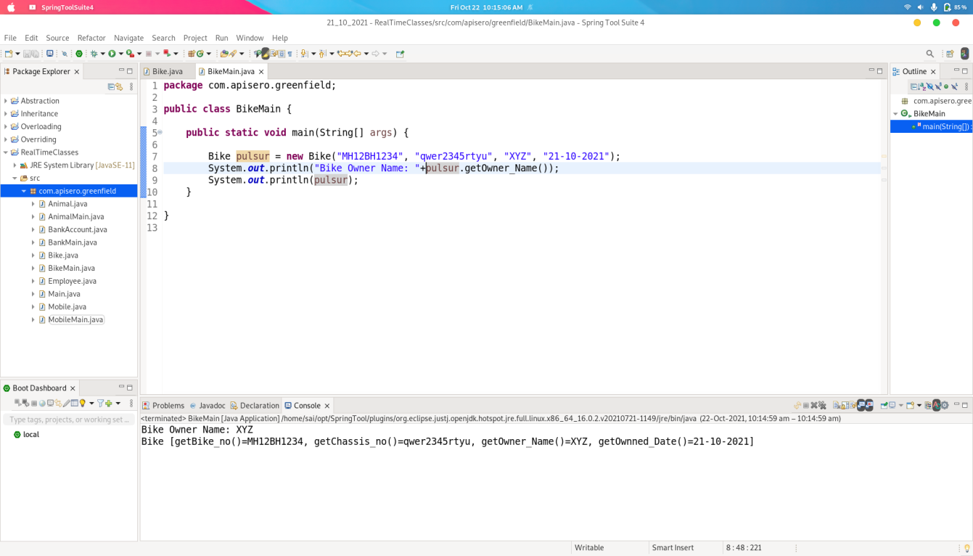

**Source Code -**

Animal.java

**package** com.apisero.greenfield;

**public** **class** Animal {

**private** String animal_name;

**private** String catagory;

**private** String eating_habit;

**public** Animal(String animal_name, String catagory, String eating_habit) {

**super**();

**this**.animal_name = animal_name;

**this**.catagory = catagory;

**this**.eating_habit = eating_habit;

}

**public** String getAnimal_name() {

**return** animal_name;

}

**public** **void** setAnimal_name(String animal_name) {

**this**.animal_name = animal_name;

}

**public** String getCatagory() {

**return** catagory;

}

**public** **void** setCatagory(String catagory) {

**this**.catagory = catagory;

}

**public** String getEating_habit() {

**return** eating_habit;

}

**public** **void** setEating_habit(String eating_habit) {

**this**.eating_habit = eating_habit;

}

@Override

**public** String toString() {

**return** "Animal [animal_name=" + animal_name + ", catagory=" + catagory + ", eating_habit=" + eating_habit + "]";

}

}

AnimalMain.java

**package** com.apisero.greenfield;

**import** java.util.ArrayList;

**import** java.util.List;

**public** **class** AnimalMain {

**public** **static** **void** main(String[] args) {

List<Animal> s = **new** ArrayList<Animal>();

s.add(**new** Animal("Tiger", "Mammals", "Non_Vegeterian"));

s.add(**new** Animal("Lion", "Mammals", "Non_Vegeterian"));

s.add(**new** Animal("Cow", "Mammals", "Vegeterian"));

s.add(**new** Animal("Crocodile", "Raptiles", "Non_Vegeterian"));

System.***out***.println(s);

}

}

**Output:**

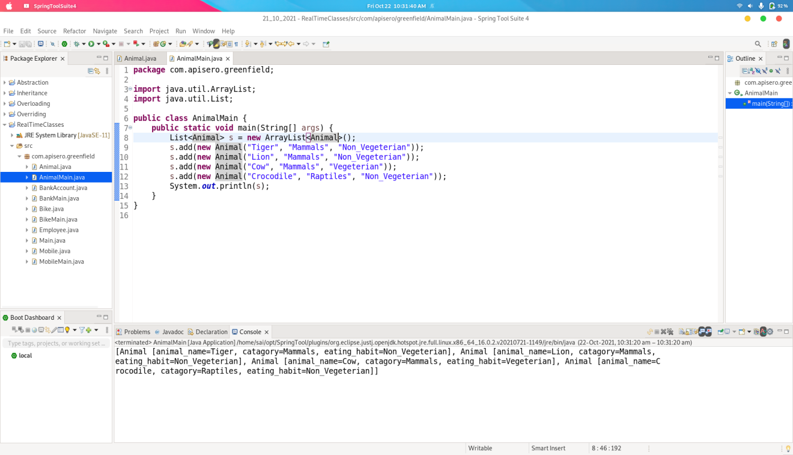

**Source Code:**

Mobile.java

**package** com.apisero.greenfield;

**public** **class** Mobile {

**private** String Name;

**private** String model_no;

**private** String release_date;

**private** **int** ram;

**private** **int** rom;

**private** String processor;

**public** Mobile(String name, String model_no, String release_date, **int** ram, **int** rom, String processor) {

**super**();

Name = name;

**this**.model_no = model_no;

**this**.release_date = release_date;

**this**.ram = ram;

**this**.rom = rom;

**this**.processor = processor;

}

**public** String getName() {

**return** Name;

}

**public** **void** setName(String name) {

Name = name;

}

**public** String getModel_no() {

**return** model_no;

}

**public** **void** setModel_no(String model_no) {

**this**.model_no = model_no;

}

**public** String getRelease_date() {

**return** release_date;

}

**public** **void** setRelease_date(String release_date) {

**this**.release_date = release_date;

}

**public** **int** getRam() {

**return** ram;

}

**public** **void** setRam(**int** ram) {

**this**.ram = ram;

}

**public** **int** getRom() {

**return** rom;

}

**public** **void** setRom(**int** rom) {

**this**.rom = rom;

}

**public** String getProcessor() {

**return** processor;

}

**public** **void** setProcessor(String processor) {

**this**.processor = processor;

}

@Override

**public** String toString() {

**return** "Mobile [Name=" + Name + ", model_no=" + model_no + ", release_date=" + release_date + ", ram=" + ram

+ ", rom=" + rom + ", processor=" + processor + "]";

}

}

MobileMain.java

**package** com.apisero.greenfield;

**import** java.util.ArrayList;

**import** java.util.List;

**public** **class** MobileMain {

**public** **static** **void** main(String[] args) {

List<Mobile> l = **new** ArrayList<Mobile>();

l.add(**new** Mobile("Samsung", "Note10", "12-10-2018", 6, 128, "Snapdragon 855+"));

l.add(**new** Mobile("Xiaomi", "POCO F1", "22-09-2017", 6, 128, "Snapdragon 845"));

l.add(**new** Mobile("One+", "Nord", "07-08-2020", 8, 256, "Snapdragon 760"));

System.***out***.println(l);

}

}

**Output:**

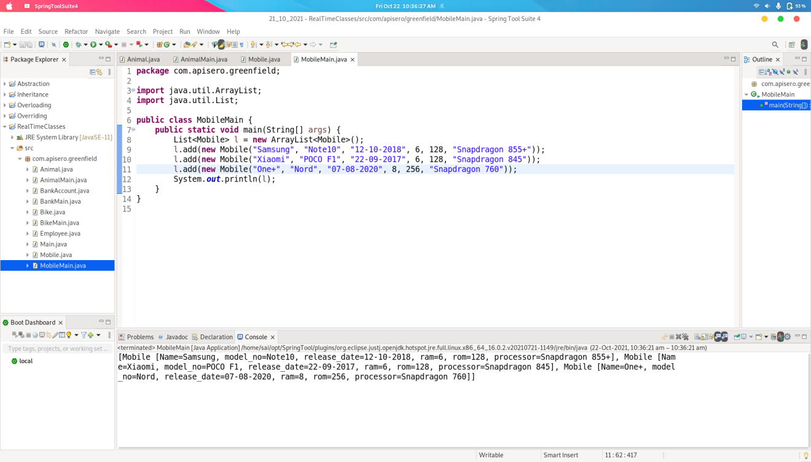

Title: 2. Create basic calculator in java.

**Source Code:**

Calculator.java

**package** com.apisero.greenfield;

**public** **class** Calculator {

**private** **int** value1;

**private** **int** value2;

**public** Calculator(**int** value1, **int** value2) {

**super**();

**this**.value1 = value1;

**this**.value2 = value2;

}

**public** **int** getValue1() {

**return** value1;

}

**public** **void** setValue1(**int** value1) {

**this**.value1 = value1;

}

**public** **int** getValue2() {

**return** value2;

}

**public** **void** setValue2(**int** value2) {

**this**.value2 = value2;

}

**public** **int** add()

{

**return** value1+value2;

}

**public** **int** sub()

{

**return** value1-value2;

}

**public** **int** mult()

{

**return** value1*value2;

}

**public** **int** divide()

{

**return** value1/value2;

}

}

Main.java

**package** com.apisero.greenfield;

**import** java.util.Scanner;

**public** **class** Main {

**public** **static** **void** main(String[] args) {

**int** choice,value1,value2;

**char** ch;

Scanner sc = **new** Scanner(System.***in***);

System.***out***.println("-----------------------------------------------------");

System.***out***.print("Enter Value 1: ");

value1 = sc.nextInt();

System.***out***.print("Enter Value 2: ");

value2 = sc.nextInt();

Calculator c = **new** Calculator(value1,value2);

**do**

{

System.***out***.println("-----------------------------------------------------");

System.***out***.print("1. Addition\n2. Substraction\n3. Multiplication\n4. Division\n Enter Your Choice: ");

choice = sc.nextInt();

**switch**(choice)

{

**case** 1:

System.***out***.println(c.add());

**break**;

**case** 2:

System.***out***.println(c.sub());

**break**;

**case** 3:

System.***out***.println(c.mult());

**break**;

**case** 4:

System.***out***.println(c.divide());

**break**;

**default**:

System.***out***.println("Enter Proper Choice....");

}

System.***out***.print("Do you want to Continue: ");

ch = sc.next().charAt(0);

}**while**(ch == 'y');

}

}

**Output:**

